Name:- Abdul Ahad Khan

Topic:- Tasks lists 2

* Part 1

a. Region-wise number of customers

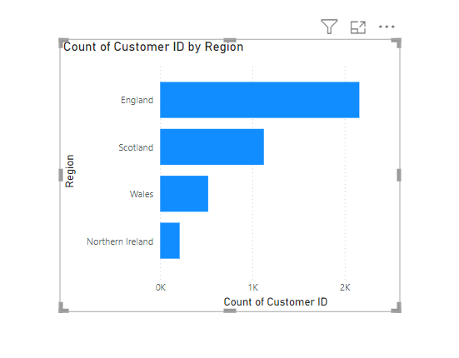

b. Region-wise number of Male & Female Customers

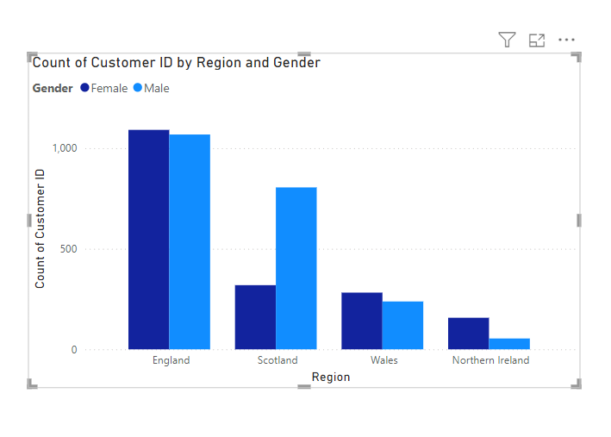

c. Customer presence throughout the world (based on the region-wise customer base)

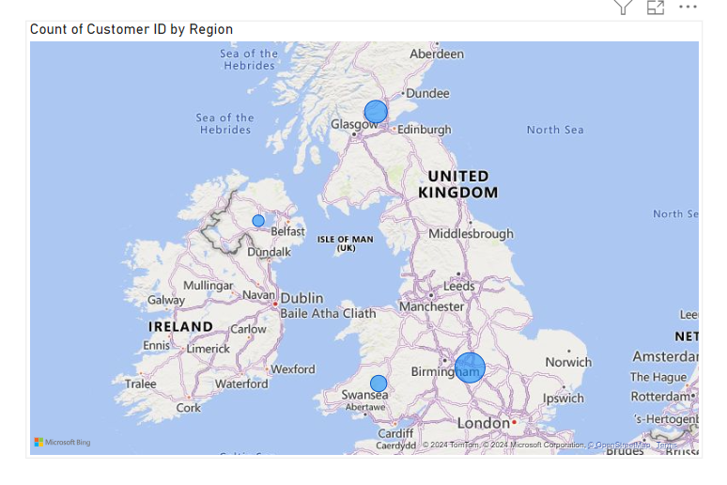

d. Region-wise customer’s bank balance

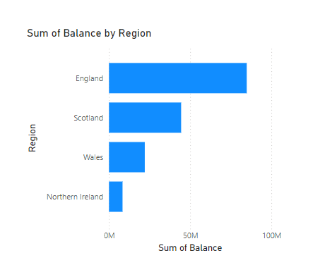

e. Region-wise Monthly balance availability trend.

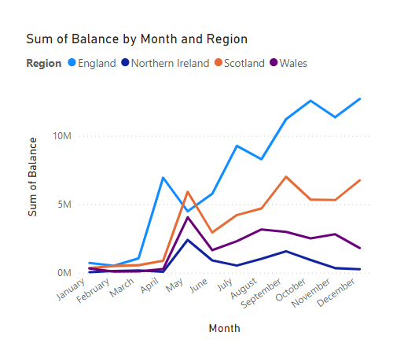

* Part 2

a. Overall profit percentage and commission for sales against each sales representative

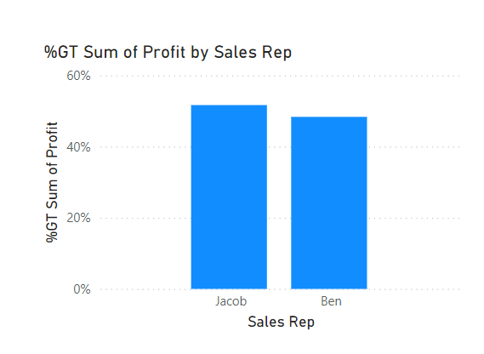

b. Sales representative-wise total number of work shifts (monthly basis) and work shifts (day & night) trends against the sales representative

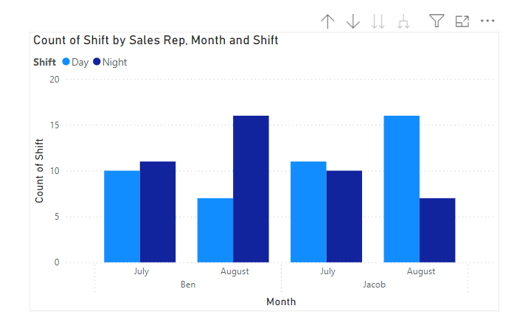

c. What are the areas you find for further improvement in terms of business product sales?

* Focus on adjusting pricing for low-margin products and identify underperforming sales reps.
* Optimize shifts and staffing based on profitable hours and weekdays.

d. In which work shift does the sales representative mostly work?

* Sales reps mostly work the **Day shift**.

e. Is there any additional impact you find in business in terms of product sales trends?

* Sales appear to fluctuate based on weekdays and shifts, indicating the need for targeted promotions and staffing adjustments.